THE INCUBATOR HUB
AINOW
( BOOTCAMP)



Insurance Claim Prediction Documentation

A Comprehensive Technical Project Report Performed

BY

HASSAN YUSUF AFOLABI

LUNGS CANCER AI/ML DOCUMENTATION

Submitted in partial fulfillment and in accordance with the requirement
for the certification in Data Science And Machine Learning
Speciality : (DS/ML) Data Science And Machine Learning

Supervisors/ Facilitators’

Israel Odeajo
AI & Machine Learning Engineer | Data Scientist Fellow, GPSDD, USA

Ezekiel Ogundepo
| Data Scientist | Statistician | Researcher | Research Software Engineer

GITHUB LINK;
https://github.com/HasanSCULPT/CAPstone_Project-INSURANCE-CLAIM-PREDICTION
Chapter 1
Introduction

BACK GROUND STUDY TO PROJECT

Insurance companies face significant financial risk from unexpected claims. Early identification of high-risk buildings enables better underwriting, pricing, and preventive interventions. This study aims to develop a predictive model that estimates the probability that a building will experience at least one insurance claim during its insured period, using only building-level characteristics available at policy inception.

Chapter 2: Problem Definition
The task is formulated as a binary classification problem: - Target variable Claim = 1 if the building has at least one claim during the insured period - Claim = 0 otherwise
The objective is not merely prediction accuracy but risk ranking, interpretability, and alignment with insurance business priorities.

Chapter 3: Data Understanding
The dataset contains structural, temporal, protection-related, and geographic features describing insured buildings. Initial inspection revealed: - Right-skewed distributions for size-related variables , Presence of outliers corresponding to large buildings , Mixed data types including numerical, boolean, and one-hot encoded categorical variables
Outliers were retained due to their domain relevance, as large buildings naturally carry higher exposure.

Chapter 4: Data Preprocessing and Feature Engineering
Key preprocessing steps included: - Consistent encoding of categorical variables using grouped one-hot encoding, Boolean normalization , Feature alignment to ensure reproducibility
Feature engineering steps: Log_Building_Dimension created to reduce skewness while preserving exposure information - Protection_Score engineered by combining correlated protection features

#To Create an optional Protection_Score

#Combine correlated protection features

#Instead of 3 perfectly correlated variables:

#This is purposely for insurance logic.

df['Protection_Score'] = (

df['Building_Painted'] +

df['Building_Fenced'] +

df['Garden']

)

# To Inspect distribution

df['Protection_Score'].value_counts().sort_index()

Protection_Score
0 7
1 3601
2 1772
3 1780
Name: count, dtype: int64

Chapter 5: Exploratory Data Analysis
PERFORMINED EDA EXPLORATORY DATA ANALYSIS
Exploratory analysis employed distribution plots, boxplots, and correlation heatmaps. Findings included: - Strong association between building size and claim occurrence - Moderate correlations among structural features - No severe multicollinearity issues

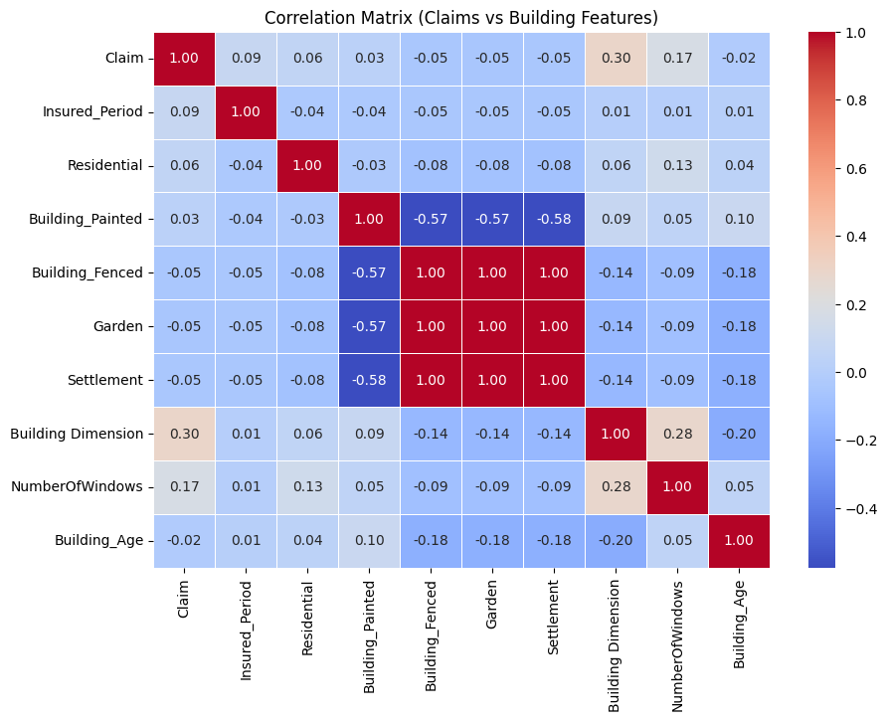

Plate,1: correlation heatmap Plot

Plate,2: Distribution & Outlier Analysis Plot
intended for Numerical variables observation only

Chapter 6: Modeling Strategy
Three models were evaluated: 1. Baseline Random Forest 2. Tuned Random Forest using RandomizedSearchCV 3. Logistic Regression benchmark with scaling and class balancing
Evaluation was based primarily on ROC-AUC due to class imbalance.
# MODEL COMPARISON (CAPSTONE TABLE)
pd.DataFrame({
'Model': ['Logistic Regression', 'Random Forest (Baseline)', 'Random Forest (Tuned)'],
'ROC_AUC': [
log_auc,
rf_auc,
rf_tuned.best_score_
]
})
 | Model | ROC_AUC
0 | Logistic Regression | 0.702178
1 | Random Forest (Baseline) | 0.695257
2 | Random Forest (Tuned) | 0.719967

Chapter 7: Model Evaluation and Threshold Optimization
The tuned Random Forest achieved an ROC-AUC of approximately 0.72, outperforming the benchmark. A business-aligned probability threshold of 0.30 was selected to minimize false negatives, reflecting insurance risk priorities.

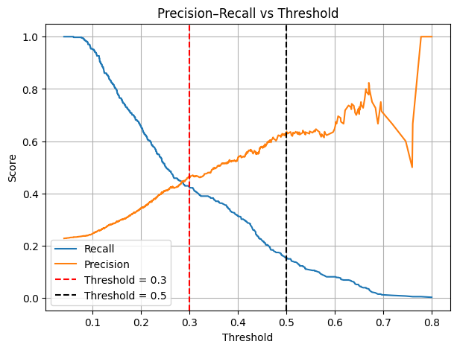
Plate,3: Threshold Optimization Curve Plot
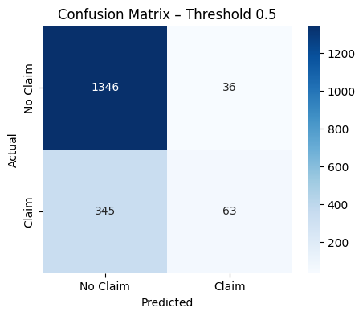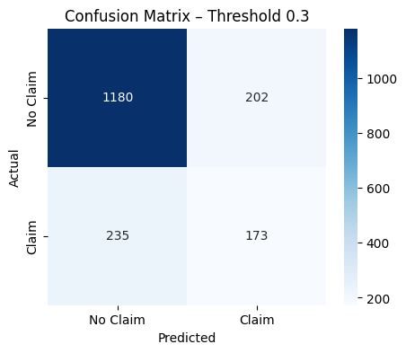

Plate,4: Confusion Matrix Plot

#Confusion Matrix at Business Threshold (0.3)
cm_03, report_03 = evaluate_threshold(y_test, rf_tuned_probs, threshold=0.3)

cm_03
print(report_03)

precision recall f1-score support

0 0.834 0.854 0.844 1382
1 0.461 0.424 0.442 408

accuracy 0.756 1790
macro avg 0.648 0.639 0.643 1790
weighted avg 0.749 0.756 0.752 1790

Chapter 8: Model Explainability
Permutation feature importance was used to assess global explainability. Results showed: Building Dimension and Log_Building_Dimension as dominant drivers - Insured Period as a key exposure variable - Structural features acting as secondary modifiers

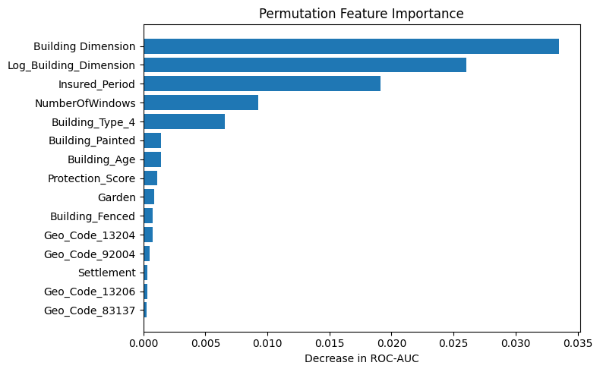
Plate,5: Permutation Plot

Chapter 9: Model Persistence and Validation
The final model, feature schema, and decision threshold were saved using joblib. Reload testing confirmed reproducibility and prediction stability.
#This is For Reload Test to Ascertain reproducibility

# Reload artifacts
model = joblib.load("final_random_forest_claim_model.pkl")
threshold = joblib.load("claim_decision_threshold.pkl")
features = joblib.load("model_feature_columns.pkl")

# Align features
X_test_aligned = X_test[features]

# Predict
probs = model.predict_proba(X_test_aligned)[:, 1]
preds = (probs >= threshold).astype(int)

preds[:10]
array([1, 0, 0, 0, 0, 0, 0, 1, 0, 0])

Chapter 10: Conclusion and Future Work
The final model is robust, interpretable, and business-aligned. Future improvements include periodic retraining, threshold recalibration, and integration of external risk data such as weather or crime statistics.

